**Download**

1. Go to URL <https://github.com>
2. Sign-in and navigate to the “Jibe-Automation-Testing”

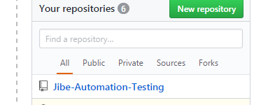

1. Click below Clone or Download button and then click on ZIP download.

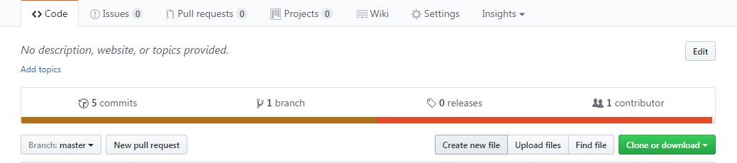

1. Unzip the file downloaded (eg: C:\\ Jibe-Automation-Testing)

**Configuration**

1. Create new project “Jibe-Automation-Testing” in Eclipse.
2. Move downloaded files from “C:\\ Jibe-Automation-Testing “to workspace folder in “Jibe-Automation-Testing” (e.g.” C:\\ Jibe-Automation-Testing”)
3. Open Eclipse-> Jibe-Automation-Testing 🡪Right Click 🡪Refresh
4. Jibe-Automation-Testing 🡪Right Click 🡪 Build Path 🡪 Configure Build Path 🡪 Click Libraries 🡪Select All Jar files Except ”JRE System Library [JavaSE-1.8]” and “TestNG” 🡪Click on Remove 🡪Click Ok

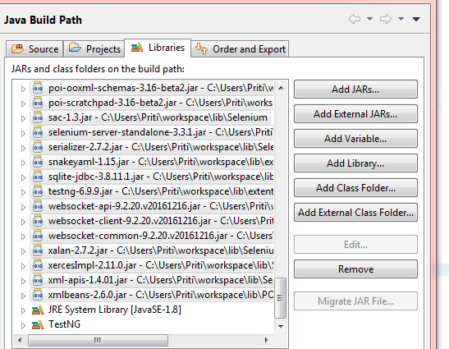

1. Jibe-Automation-Testing 🡪Right Click 🡪 Build Path 🡪 Configure Build Path 🡪 Click on Libraries 🡪Add External JARs 🡪 Go to Workspace 🡪JibeAutomation (Project Name) 🡪src 🡪Libraries and Add all POI, Selenium, Extent Report, ANT Jar files 🡪Apply 🡪OK ( e.g. “\\workspace\\JiBeAutomation\\src\\Libraries”)

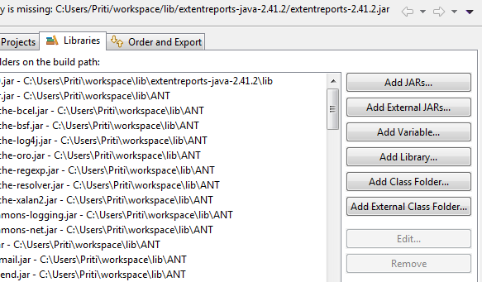

1. Click on Apply 🡪OK

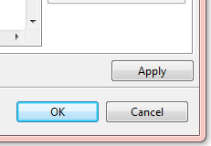

1. Open RW .java class

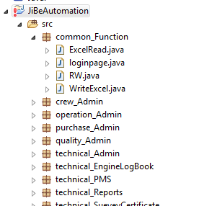

1. Change Workspace Excel path as per Your Project Excel path and Save

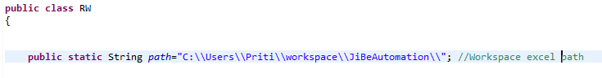

1. Go to JibeAutomation 🡪 src 🡪 TestCases 🡪 In WebDriverPass class , change Chrome path as per your (JibeAutomation) project Location

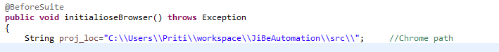

**Execution Steps**

1. Go to XML File and expand it 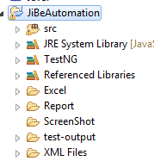
2. Right click on any(e.g.”Technical.xml”) one file for the Execution 🡪Run As 🡪TestNG

